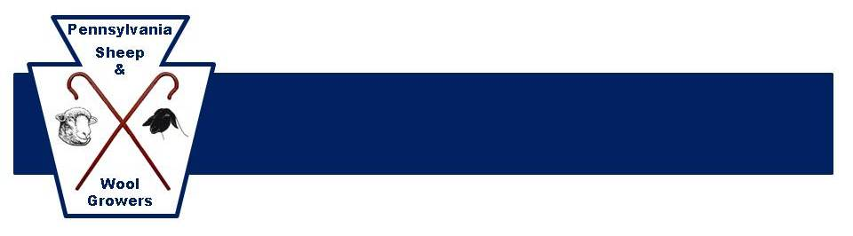
LAMB MARKETING DIRECTORY

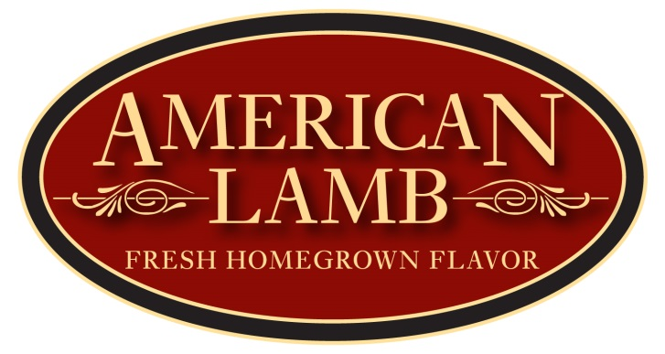

Looking for lamb? We can help!
Fresh from our local farms to you!

*Made possible by a grant with the American Lamb Board

Maple Hollow Farm
Brian & Melanie Barkley 9027 Hyndman Rd., Manns Choice, PA 15550
814-623-5756 Bedford County
maplehollow@embarqmail.com www.maplehollow.net
Offering: Whole lambs, Other products

Fruit Hill Farms
Darrell & Christina Becker 295 Krepps Ln., East Millsboro, PA 15433
724-785-9434 Fayette County
canddbecker@gmail.com
Offering: Whole lambs, Other products
Offering wholesome naturally fed lamb, beef, pork, and goat. Antibiotic free and no added hormones.

Little Hooves Romneys
Charlene Carlisle 510 Centerton Rd., Moorestown, NJ 08057
609-760-0399 Burlingon County
ccshep1@aol.com www.littlehoovesromneys.com
Offering: Whole lambs, Lamb cuts, Other products
Farm fresh and locally grown.

Grube Family Farm
Dennis or Kathy Grube Meyersdale, PA
814-634-5118 Somerset County
dgrubefam@hotmail.com
Offering: Whole lambs
Naturally raised lamb in the Laurel Highlands of Somerset County, PA.

Michael T Harper 814 Torrey Ln., Boalsburg, PA 16827
610-310-4896 Centre County
mth174@gmail.com
Offering: Whole lambs, Other products
Naturally raised on pasture

Silvara Valley Farm
Fred Hemmerly 7758 Route 367, Laceyville, PA 18623
570-869-2692 Bradford County
silvaravalleyfarm@earthlink.net www.silvaravalleyfarm.com
Offering: Whole lambs
We raise Texel lambs

Nix Besser Farm
Robert D. & Betty W. Herr 5909 Division Hwy., Narvon, PA 17555
717-354-5640 Lancaster County
drherr5909@comcast.net
Offering:
Registered Dorper Sheep, Registered Boer Goats and sheep/goat order buying and consulting.
Brindle Hill
Lynda Heise
571-278-4330 Franklin County
brindlehill@earthlink.net
Offering: Whole lamb
Pasture raised lamb, Antibiotic free, No Added Hormones

Hillside Shepherd
Greg & Laurie Hubbard 1384 State Route 239, Huntington Mills, PA 18622
570-864-6027 or 814-932-9000 Luzerne County
psushepherd@yahoo.com
Offering: Whole lambs, Lamb cuts
Wholesome and Delicious Lamb that is Pasture Raised, Antibiotic Free with No Added Hormones!

Shepherd’s Farm
Shirley or Joan Knoblach 7542 Kingwood Rd., Confluence, PA 15424
814-395-5562 Somerset County
Offering: Lamb cuts
Pasture Raised, No Added Hormones

JMM Angus
Mike Molnar 2259 Avella Rd., Avella, PA 15312
724-587-5987 or 412-916-4577 Washington County
mmolnar1@verizon.net
Offering: Whole lambs
All natural grain fed whole lambs.

Lane’s End Farm
Jan Motter 12211 W Rt. 973, Jersey Shore, PA 17740
570-398-2078 Lycoming County
Mottersheep1@verizon.net
Offering: Whole lambs
Whole lambs and lamb sausage. Antibiotic Free, Grass and Whole Grain Fed. Deliciously healthy!

Owens Farm
Caroline Owens 2611 Mile Post Rd., Sunbury, PA 17801
570-286-5309 Northumberland County
caroline@owensfarm.com www.owensfarm.com
Offering: Whole lambs, Other products
Grass-fed lamb, Custom cut and packaged to fit your recipes. Whole or half.

Mahantango Sheep Co.
John Roemer 334 Mill Rd., Mount Pleasant Mills, PA 17853
570-809-3298
Offering: Whole lambs
Solely grass fed Katahdin lambs.

Bearlin Acres Farm
Linda Singley 180 Mt. Ash Ln., Shippensburg, PA 17257
717-530-3605 Franklin County
bearlin@pa.net www.bearlinacres.com
Offering: Whole lambs, Lamb cuts, Other products
From the Farm to You! USDA local abattoir custom cuts to your specifications.
K Bar K Farm
Ken & Kathy Soder 5867 Eberle Rd., Petersburg, PA 16669
814-669-1374 Huntingdon County
info@kbarkfarm.com www.kbarkfarm.com
Offering: Whole lambs
Forage-raised, production-style Dorsets

Baytree Farm
Warren K. Thomas 2265 Rockland Nickleville Rd., Emlenton, PA 16373
814-671-3922 Venango County
warren@baytreefarm.com www.baytreefarm.com
Offering: Whole lambs
Producing delicious grassfed lambs, humanely raised without added hormones, antibiotics, or grain.

Mercer Cottage Farm
David & Ariel Thompson 315 McKinley Ave. Ext., Mercer, PA 16137
724-662-4394 or 724-699-1636 Mercer County
Offering: Whole lambs, Lamb cuts
Pasture raised, No added hormones, Steroid free lamb. We strive to meet your needs!

Wherry’s Farm
L. George Wherry 526 Spring Valley Rd., Scenery Hill, PA 15360
724-554-1443 Washington County
wherrysfarm@ymail.com
Offering: Whole lambs
Naturally raised, good quality whole lambs.

ADDITIONAL RESOURCES:

Pennsylvania Sheep & Wool Growers Association
www.pasheep.com

American Lamb Board
www.americanlamb.com
www.leanonlamb.com

